ABSTRACT
Gesture Controlled Car is a robot which can be controlled by simple human gestures. The user just needs to wear a gesture device in which a sensor is included. The sensor will record the movement of hand in a specific direction which will result in the motion of the robot in the respective directions. The robot and the Gesture instrument are connected wirelessly through radio waves. User can interact with the robot in a more friendly way due to the wireless communication. We can control the car wearing a small transmitting device in our hand or wrapping it on the elbow which includes an accelerometer. The sensors are intended to replace the remote control that is generally used to run the car. It will allow user to control the forward, backward, leftward and rightward movements, while using the same accelerometer sensor to control the throttle of the car.

Chapter 1:-Introduction and background of the Industry or User based problem
Introduction:-
There are a large number of commercial remote controllers in the market. Some top brands of remotes are Logitech, Sideclick, and Vizio. Their latest remotes consist of buttons, small touchscreens, and joysticks in cases of toy cars and drones. With those remotes, users can conduct a large variety of control patterns. However, there’s still no control mechanism that utilizes part of the user’s body to perform direct controls in the market. As a result, even though we will only design a band that does a very limited range of control patterns, this control mechanism is innovative and helpful. Moreover, it’s not hard to add in more control functionalities once the whole system works.
If human can control machines totally by their voice, gestures and other activities, then interactions will be easier. There are many high tech cars which can do these things. Our target is to make hand gestured car for disabled people and those who has amputated limbs not only that but it will be easier to operate the car by hand gesture. Our dream is to make travelling easier and fun for disabled people and those who have amputated limbs. The car works on gesture sensors, accelerometer, day-night sensors etc. Gesture Controlled robot is a kind of robot which can be controlled by our hand gestures not by old buttons.
In this system, a gesture driven robotic vehicle is developed, we just need to wear a small transmitting device in our hand or wrap it on the elbow which includes an accelerometer. This will transmit an appropriate command to the car so that it can do whatever we want, it also includes headlights made with day-night sensor which prevents the disabled person from pressing any button. The vehicular movements i.e. handling and control, depends on the gesture of the user. In this system, gesture is captured by accelerometer which is mounted on person's hand and are forwarded to micro-controller and encoder circuit. This encoded signal is transmitted by RF transmitter. In the receiver section, the RF receiver holds down the received signal and after decoding it is processed with micro-controller and gives those parameters to the robotic vehicle so that it acts accordingly to the gesture.

Chapter 2:-Literature Survey for Problem Identification and Specification
Problem Identification:-

The traditional wired buttons controlled robot becomes very bulgy and it also limits the distance the robot goes. The Wireless Hand controlled Robot will function by a wearable hand glove from which the movements of the hand can be used as the input for the movement of the robot. The basic idea of our project is to develop a system (Robot) which can recognize the Human Interaction with it to accomplish the certain tasks assigned to it. In our project we will design a wearable Hand Glove which will contain the sensors mounted on it to capture the movement of the hand and convert the raw mechanical data into electrical form. This data will be further processed and converted into an understandable format for the lilypad mounted on the Glove. This lilypad will act as a transmitter of the data for wireless communication purpose. Once the transmitted data is received by the receiver module which will be connected to the Microcontroller, it will be processed and further sent to the Microcontroller. Microcontroller will deduce the commands and accordingly it will actuate the motor drivers to control the Motors for various tasks on the robot

Literature Survey for Problem Identification

1) A Hand-Gesture-Based Control Interface for a Car-Robot
(Mu-Chun Su and Pa-Chun Wang)
Conference Paper in Proceedings of the ... IEEE/RSJ International Conference on Intelligent Robots and Systems. IEEE/RSJ International Conference on Intelligent Robots and Systems October 2010

2)Modeling and Designing of Gesture Control Robot
(Harpreet Kaur Channi)
IJSART - Volume 3 Issue 10 – OCTOBER 2017

Abstract:-This paper presents a model for gesture controlled user interface (GCUI), and identifies trends in technology, application and usability. It is an integrated approach is real time detections, gesture based data which control vehicle movement and manipulation on gesture of the user using hand movements. A three-axis accelerometer is adaption. As the person moves their hand, the accelerometer also moves accordingly. The gesture is capture by accelerometer and processed by gesture. Today human machine interactions, is moving away from mouse and pen and is becoming pervasive
and much mouse compatible with the physical world. With each passing day, the gap between machines and human is being reduced with the introduction of new technology is easy the standard of living. Its having future scope of advanced robotic arms that are designed like the human hand itself can easily controlled using hand gesture only. It also having proposed utility in field of construction, medical science, hazardous waste disposal etc.
3)Hand Gesture Controlled Robot Car
(Chirag Kaushik)
Imperial Journal of Interdisciplinary Research (IJIR) Vol-3, Issue-5, 2017

Abstract: - In this advanced world robotics are playing key role for boosting up the living standard of humans and reducing the requirement of man power in society . So, keeping this thing in mind this paper presents in detail a robotic system that allows users, especially non‐expert programmers, to instruct a robot just showing it what it should do. This is done using the most natural human interfaces (gestures) instead of using of old buttons. Special attention will be given to the recognition of gestures, where the data extracted from a motion sensor (three‐axis accelerometer) on the remote (transmitter) of system is transmitted to receiver through encoder and decoders. This paper presents an alternative to the typical gesture controlled robot where potentiometers of transmitter were more prone to get deflected from its optimum position and were difficult to carry in hand for providing perfect gesture.

4) An Automated Robot-Car Control System with Hand-Gestures and Mobile Application Using Arduino
(Dr. Saleem Ullah, Zain Mumtaz, Shuo Liu and Mahboob, A.)
2019 by the author(s). Distributed under a Creative Commons CC BY
license.

Abstract: Gesture recognition has always been a technique to decrease the distance between the physical and the digital world. In this work, we introduce an Arduino based vehicle system which no longer require manual controlling of the cars. The proposed work is achieved by utilizing the Arduino microcontroller, accelerometer, RF sender/receiver, and Bluetooth. Two main contributions are presented in this work. Firstly, we show that the car can be controlled with hand-gestures according to the movement and position of the hand. Secondly, the proposed car system is further extended to be controlled by an android based mobile application having different modes (e.g., touch buttons mode, voice recognition mode). In addition, an automatic obstacle detection system is introduced to improve the safety measurements to avoid any hazards. The proposed systems are designed at lab-scale prototype to experimentally validate the efficiency, accuracy, and affordability of the systems. We remark that the proposed systems can be implemented under real conditions at large-scale in the future that will be useful in automobiles and robotics applications.

Chapter 3:-Proposed Detailed Methodology of solving Identified problem with action plan

Proposed Detailed Methodology of solving Identified problem

Recognizing Hand Movements:

The handheld controller is a 3D rigid body that can be rotated about the three Orthogonal axes. Yaw, pitch and roll are referred to as rotation. These rotation takes place as Z axis is called yaw, the next rotation X-axis is called pitch and last rotation about the Y-axis is called roll. Any orientation can be achieved by the composing those three-elemental rotation.
User vehicle interaction

1.Transmitter:

An RF transmitter module can transmit a radio wave and modulate that wave to carry data. Transmitter modules are usually implemented alongside a micro controller which will provide data to the RF module which is transmitted. RF transmitters are usually subject to regulatory requirements which dictate the maximum allowable transmitter power output.

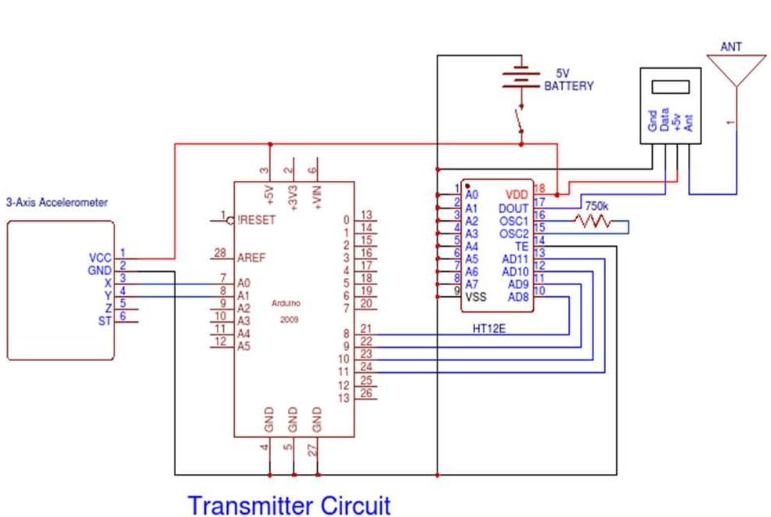

2.Receiver:

An RF Receiver module receives the modulated RF signal, and then it demodulates. There are two types of RF receiver module. Super-regenerative modules are usually of low cost and low power designs using a series of amplifiers use to extract modulated data from a carrier wave. Super-regenerative modules are generally imprecise as their frequency of operation varies in a fair amount with temperature and power supply voltage. Super heterodyne receivers having a performance advantage over super-regenerative; they offer increased in accuracy and stability over a large voltage and temperature range. This stability comes from a fixed crystal design which in turn leads to a comparatively more expensive product. Radio receiver which receives the transmitted coded signal from the transmitter are converted to digital format and output is available to the microcontroller. We based on the input coded signal, the input is given to motor driver IC and robot will behave as follows.
- Moves in forward direction
- Moves in reverse direction
- It can even turn left or right while moving forward or in reverse direction.
- In case of obstacle, moves reverse turn left or right and wait for the next instruction.
- On the spot left or right turn to pass through the narrow space

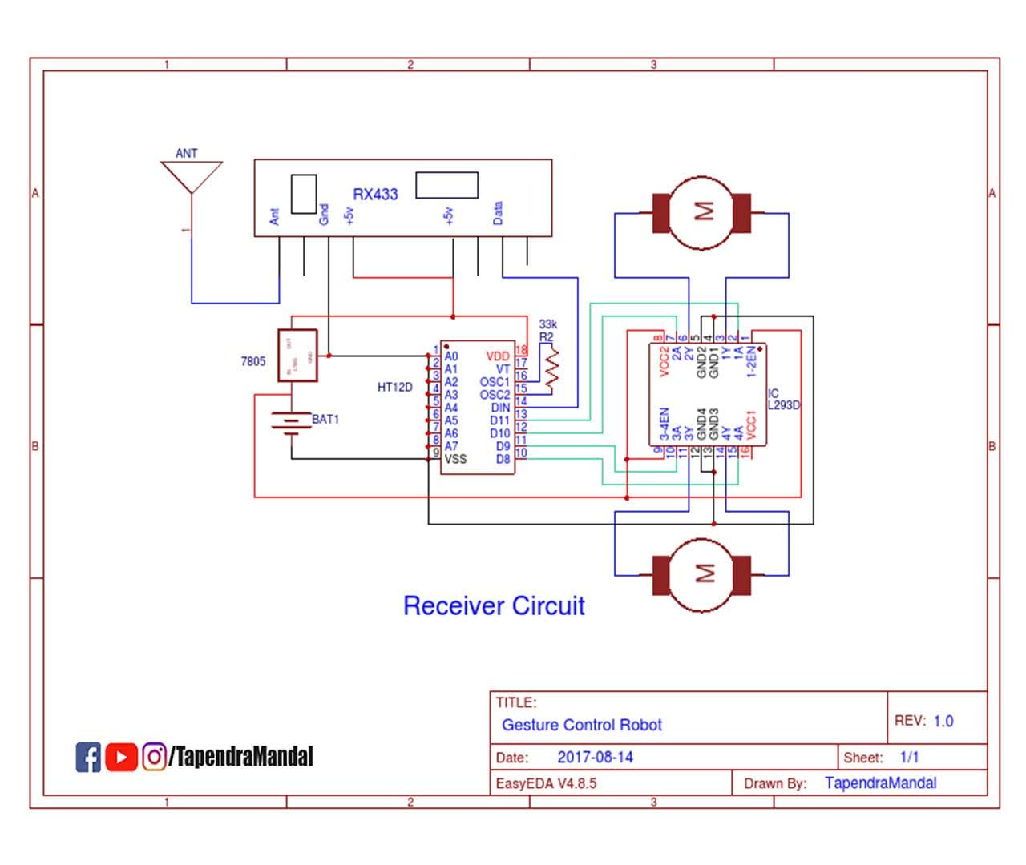

3.HT12E Encoder IC:

HT12E is an encoder integrated circuit of 2¹² series of encoders. They are paired with 2¹² series of decoders for use in remote control system applications. It is mainly used in interfacing RF and infrared circuits. The chosen pair of encoder/decoder should have same number of addresses and data format.

Simply put, HT12E converts the parallel inputs into serial output. It encodes the 12 bit parallel data into serial for transmission through an RF transmitter. These 12 bits are divided into 8 address bits and 4 data bits.

HT12E has a transmission enable pin which is active low. When a trigger signal is received on TE pin, the programmed addresses/data are transmitted together with the header bits via an RF or an infrared transmission medium. HT12E begins a 4-word transmission cycle upon receipt of a transmission enable. This cycle is repeated as long as TE is kept low. As soon as TE returns to high, the encoder output completes its final cycle and then stops.

Pin Diagram:
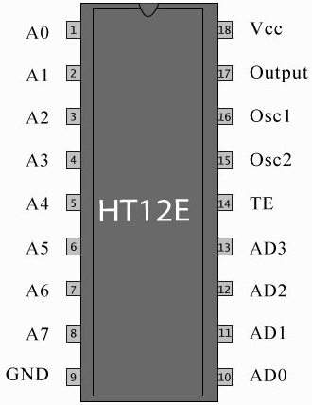

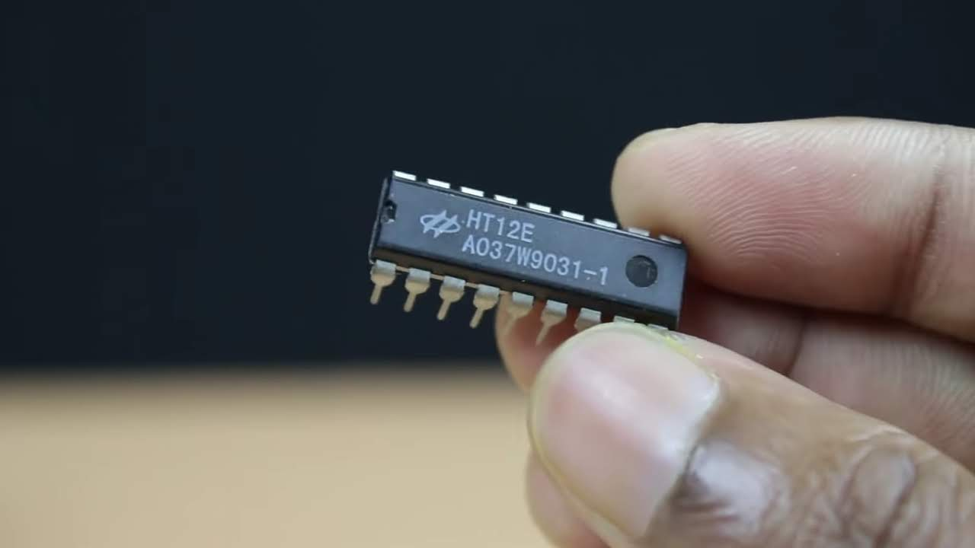

4.LilyPad Arduino 328 Main Board:

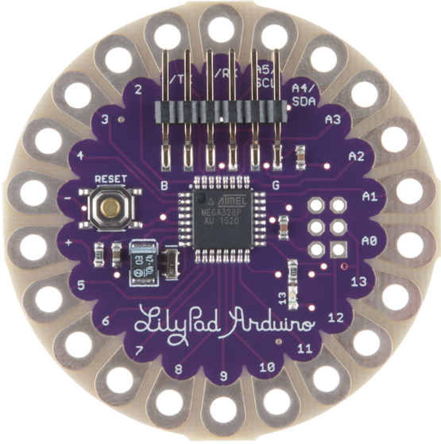
The LilyPad Arduino 328 Main Board is an Arduino-programmed microcontroller designed to be easily integrated into e-textiles and wearable projects. It offers the same functionality you find in other Arduino boards, in a lightweight, round package designed to minimize snagging and profile, with wide tabs that can be sewn down and connected with conductive thread.
The LilyPad Arduino consists of an ATmega328 with the Arduino bootloader and a minimum number of external components to keep it as small (and as simple) as possible. This board will run from 2V to 5V and offers large pin-out holes that make it easy to sew and connect. Each of these pins, with the exception of (+) and (-), can control an attached input or output device (like a light, motor, or switch).
LilyPad is a wearable e-textile technology developed by Leah Buechley and cooperatively designed by Leah and SparkFun. Each LilyPad was creatively designed to have large connecting pads to allow them to be sewn into clothing. Various input, output, power, and sensor boards are available. They're even washable.

5.RF 433MHz Transmitter/Receiver Module

RF 433 MHz Module Specifications:
- Wireless (RF) Simplex Transmitter and Receiver
- Receiver Operating Voltage: 3V to 12V
- Receiver Operating current: 5.5mA
- Operating frequency: 433 MHz
- Transmission Distance: 3 meters (without antenna) to 100 meters (maximum)
- Modulating Technique: ASK (Amplitude shift keying)
- Data Transmission speed: 10Kbps
- Circuit type: Saw resonator
- Low cost and small package

Where to use 433 MHz RF modules:
The 433MHz wireless module is one of the cheap and easy to use modules for all wireless projects. These modules can be used only in pairs and only simplex communication is possible. Meaning the transmitter can only transmit information and the receiver can only receive it, so you can only send data from point A to B and not from B to A.
The module could cover a minimum of 3 meters and with proper antenna a power supplies it can reach upto 100 meters theoretically. But practically we can hardly get about 30-35 meters in a normal test conditions.
So if you are looking for a simple wireless communication to transmit information within a short distance then these RF pair could be the right choice.

Action Plan

Week | Karan  Kurani | Riddhi  Hedaoo | Sahil  Wadgire
5/8 | Place order  for all the  components | Place order  for all the  components | Prepare for Design  Review
12/8 | Begin working on  the PCB design of  microcontroller | Start working on the  mechanical design  of the car | Start working on the  design and circuits of band
13/8 | Get correct output  data from the  accelerometer | Start working on the  design and circuits of day-night sensor | Figure out the  installation of  battery connections  and power supply  circuitry
18/8 | Make  communication  modules work on  Arduino | Complete the  reliable data transfer  from sensors to the  microcontroller | Begin using Arduino  to program the  communication  modules.
25/8 | Assemble all the  components on the  band . | Start the project proposal | Assemble the car  with all the  components on it.
1/9 | Final testing on the  entire system, and  fix all the bugs | Finish the project proposal | Final testing on all  the functionalities,  fix all the bugs.

References and bibliography.
- https://www.youtube.com/watch?v=rejZmqRrKMc&t=6s
- http://www.engineersgarage.com/contribution/accelero meter-based-hand-gesture-controlled-robot] Accessed 3 November, 2013.
- [http://www.robotplatform.com/howto/L293/motor_drive r_1.html] Accessed 5 November, 2013.
- [http://en.wikipedia.org/wiki/Gesture_interface] Accessed 5 November, 2013.
- [http://www.wisegeek.com/what-is-a-gear-motor.htm] Accessed 6 November, 2013.
- [http://en.wikipedia.org/wiki/DC_motor] Accessed 8 November, 2013.
- [http://electronics.stackexchange.com/questions/18447/w hat-is-back-emf-counter-electromotive-force] Accessed 8 November, 2013
- [www.wikipedia.com]

